Ansible Task -01

- Setup one master and two worker nodes in ansible.
Task Title
End-to-End Setup of Ansible Master–Worker Architecture on AWS EC2
Objective
To provision multiple EC2 instances on AWS, configure one instance as an Ansible Master, set up worker nodes, install and configure Ansible on Ubuntu 24.04, enable passwordless SSH authentication, and validate connectivity using Ansible ad-hoc commands.
Prerequisites
- AWS account with EC2 access
- IAM user with EC2 permissions
- Existing key pair for SSH access
- Ubuntu Server 24.04 LTS AMI
- Security Group allowing SSH (port 22)
- Basic knowledge of:
  - Linux & SSH
  - AWS EC2
  - Ansible fundamentals
Step-by-Step Implementation:
Step 1: Launch EC2 Instances
- Open AWS EC2 Console
- Click Launch Instance
- Set instance name as Ansible
- Select Ubuntu Server 24.04 LTS (Free Tier Eligible)
- Choose instance type t3.micro
- Set Number of instances = 3
Purpose:
- 1 → Ansible Master
- 2 → Ansible Worker Nodes
Step 2: Configure Key Pair and Network
- Select existing key pair NV
- Use default VPC and subnet
- Enable Auto-assign Public IP
- Select existing Security Group allowing SSH
Step 3: Verify Instances
- Navigate to EC2 → Instances
- Ensure all instances are in Running state
- Rename instances:
  - Ansible-Master
  - Ansible-Worker-01
  - Ansible-Worker-02
Step 4: SSH into Ansible Master
- Connect from local machine:
ssh -i NV.pem ubuntu@<public-ip>
- Switch to root:
sudo su -
Step 5: Verify Python Installation
- Check Python version:
python3 --version
- Python 3.12.x confirmed (required for Ansible)
Step 6: Update System Packages
- Refresh APT repositories:
apt update -y
Step 7: Install Ansible
- Install Ansible:
apt install ansible -y
Step 8: Verify Ansible Installation
ansible --version
- Confirms Ansible Core, Python path, plugins, and collections
Step 9: Create Ansible Configuration
mkdir -p /etc/ansible
touch /etc/ansible/ansible.cfg
Step 10: Configure ansible.cfg
Edit:
vi /etc/ansible/ansible.cfg
Add:
[defaults]
remote_user = root
host_key_checking = False
retry_files_enabled = False
forks = 10
Step 11: Configure Inventory File
Edit:
vi /etc/ansible/hosts
Add:
[all]
172.31.30.193
172.31.31.104
[worker-01]
172.31.30.193
[worker-02]
172.31.31.104
Step 12: Generate SSH Key Pair on Ansible Master
- Incorrect command attempted (ssh -keygen) → corrected
- Generate SSH key:
ssh-keygen
- Accept default location:
/root/.ssh/id_ed25519
- No passphrase
Step 13: View Public SSH Key
cat /root/.ssh/id_ed25519.pub
Step 14: Configure SSH on Worker-01
- SSH into Worker-01
- Navigate to SSH directory:
cd ~/.ssh
vi authorized_keys
- Paste Ansible Master public key
- Save and exit
Step 15: Configure SSH on Worker-02
- SSH into Worker-02
- Navigate to SSH directory:
cd ~/.ssh
vi authorized_keys
- Paste same public key
- Save and exit
Step 16: Validate Passwordless SSH Using Ansible
Run from Ansible Master:
ansible all -m ping
Expected result:
SUCCESS
ping: pong
Validation Steps
- Verify Ansible installation:
ansible --version
- Verify inventory:
cat /etc/ansible/hosts
- Verify Ansible connectivity:
ansible all -m ping
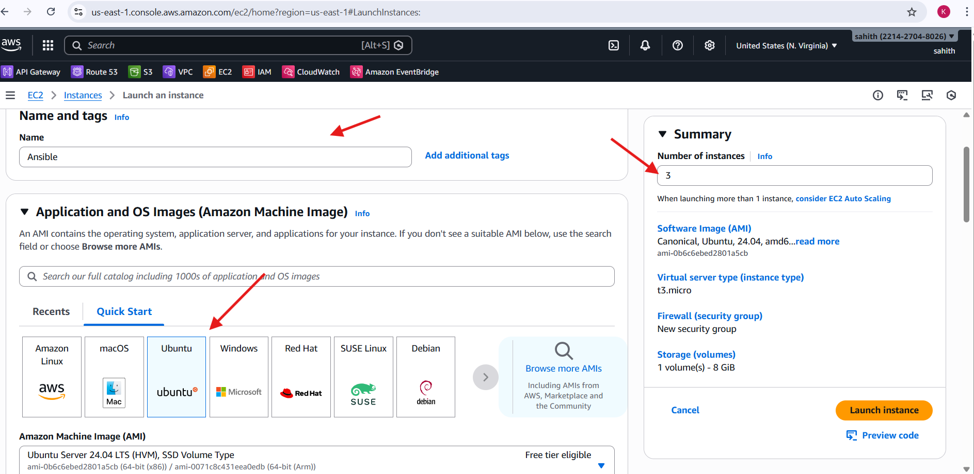
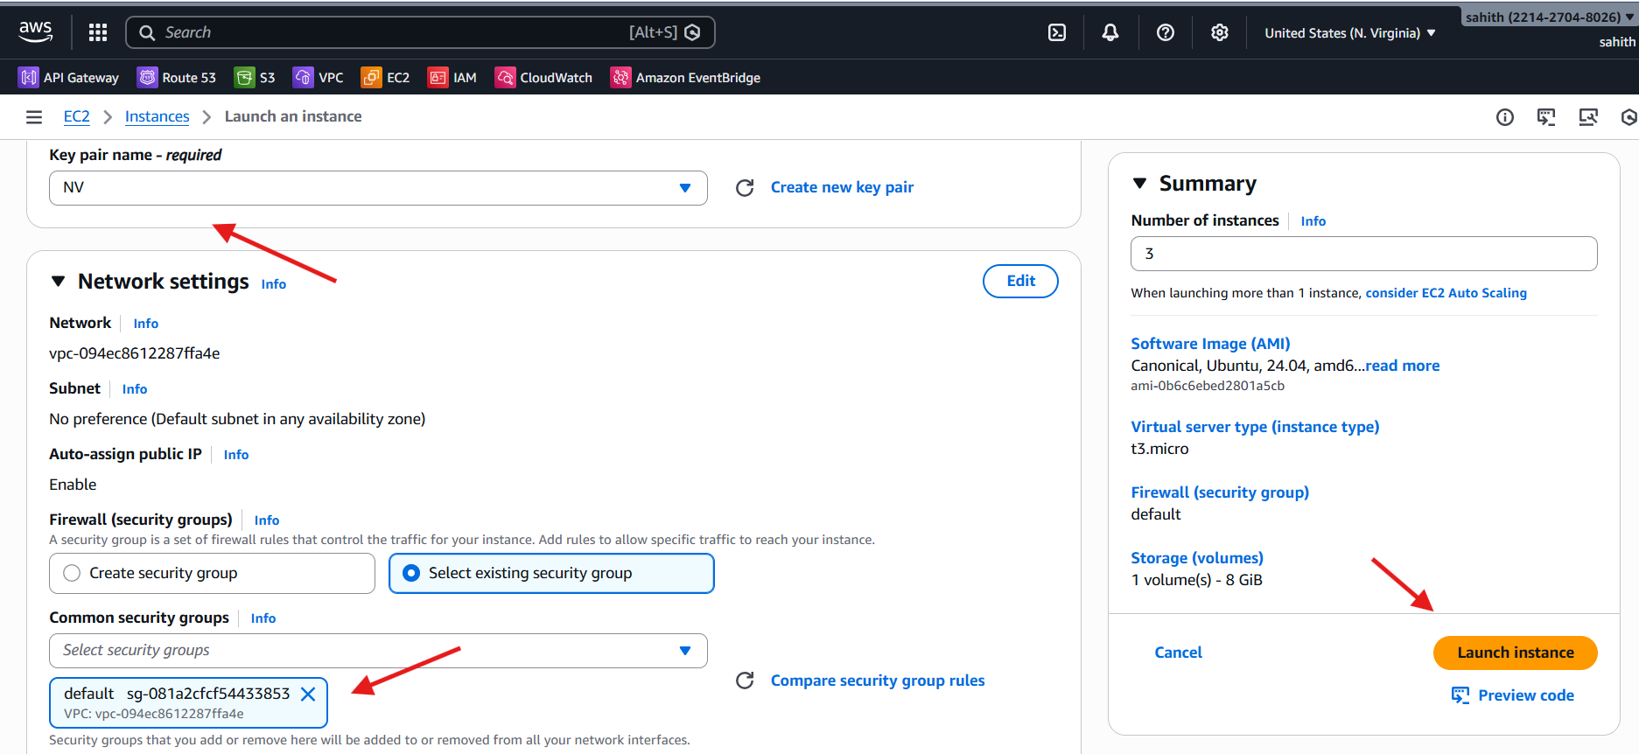
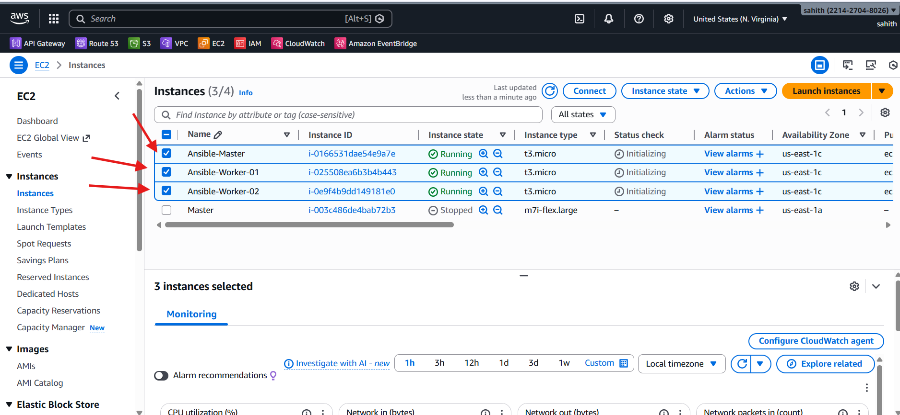
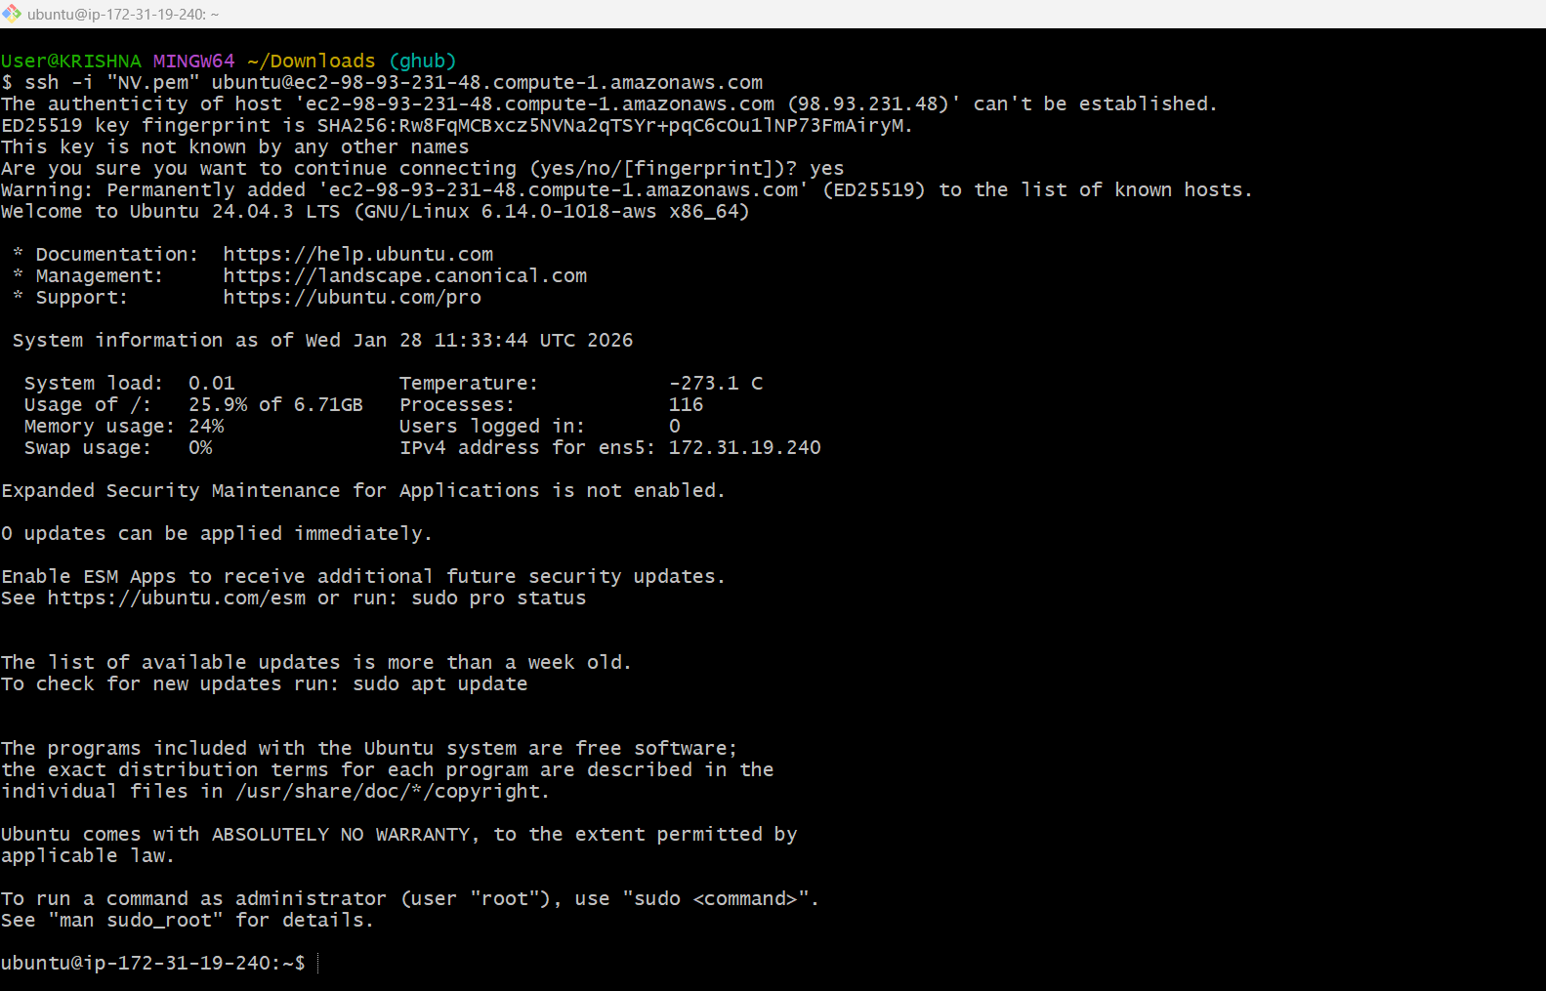
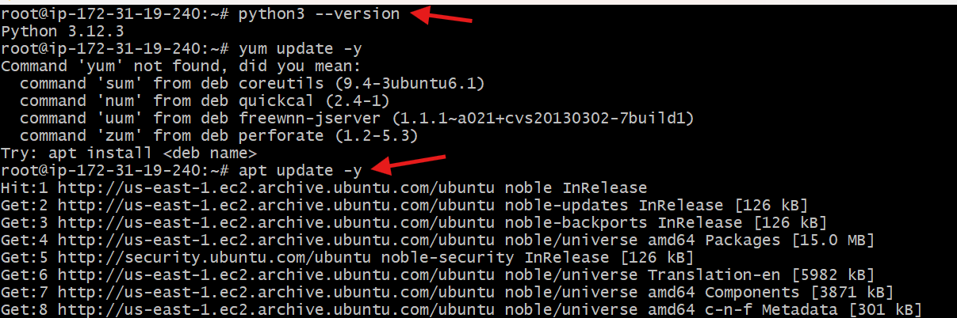
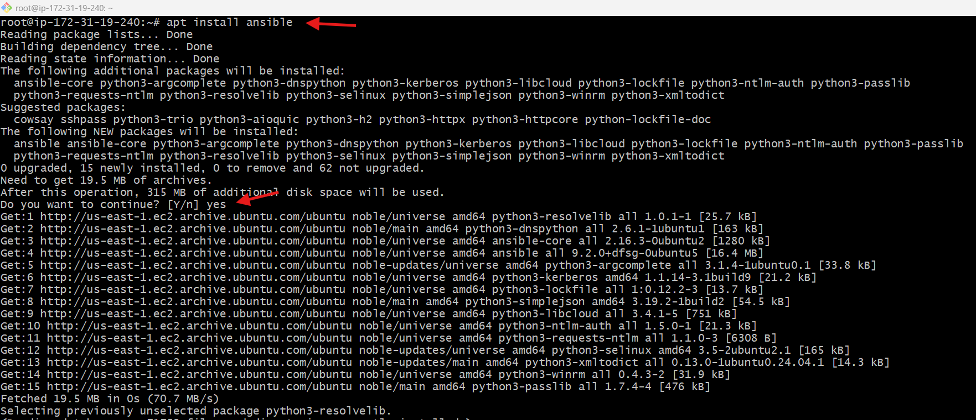
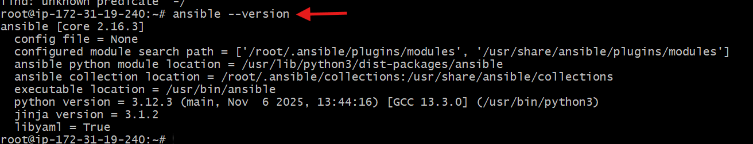
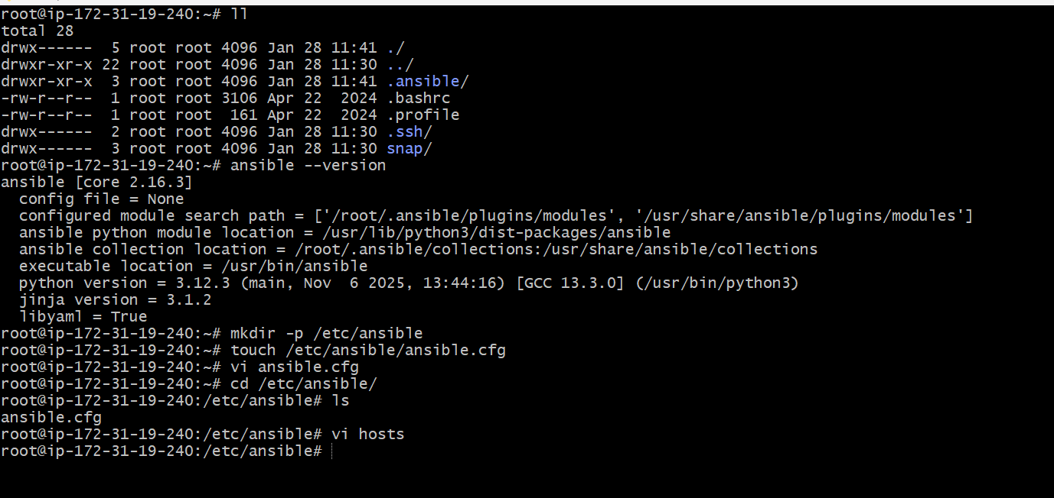
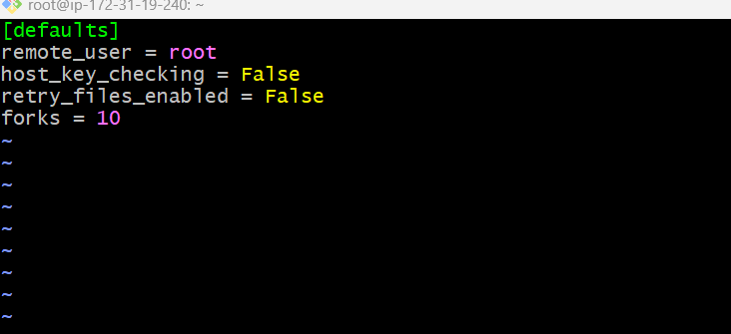
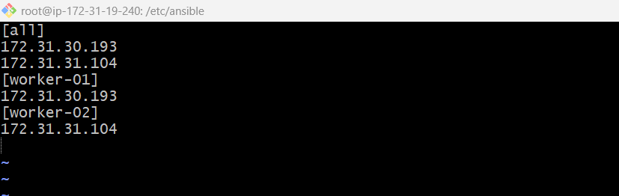
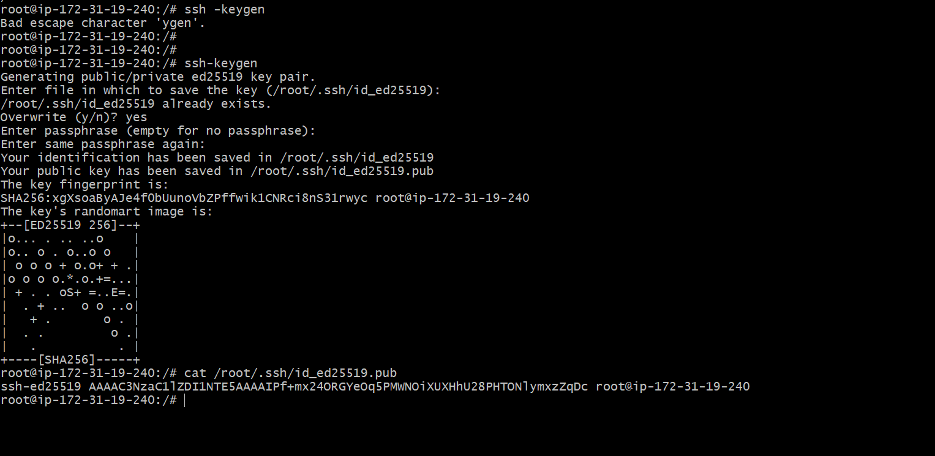
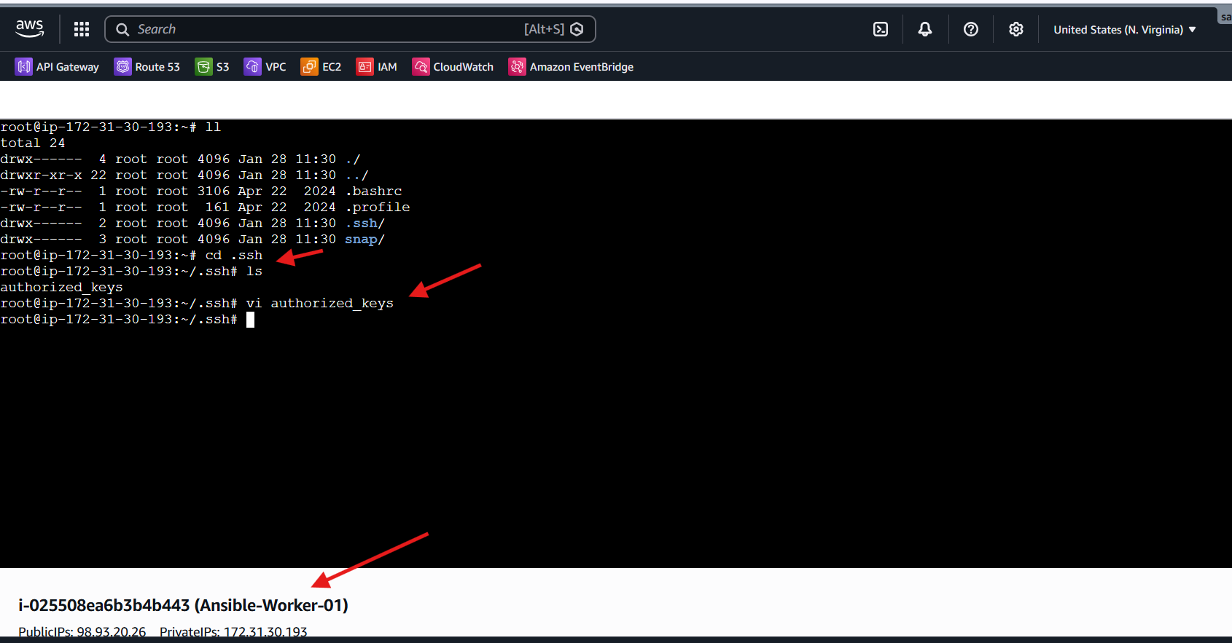
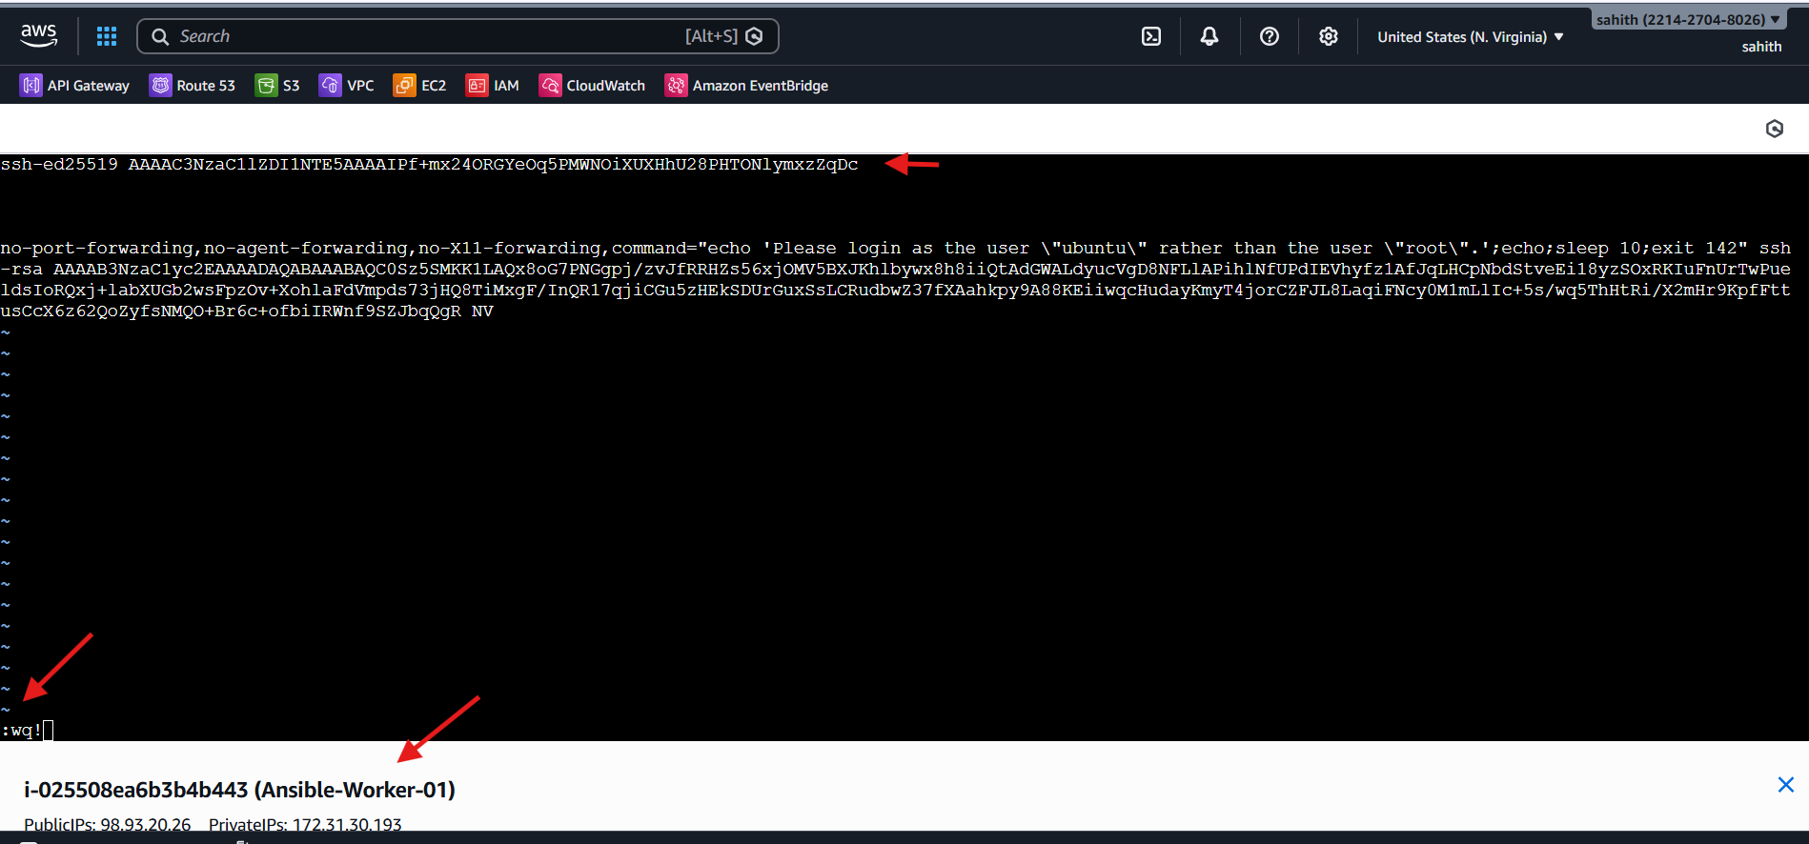
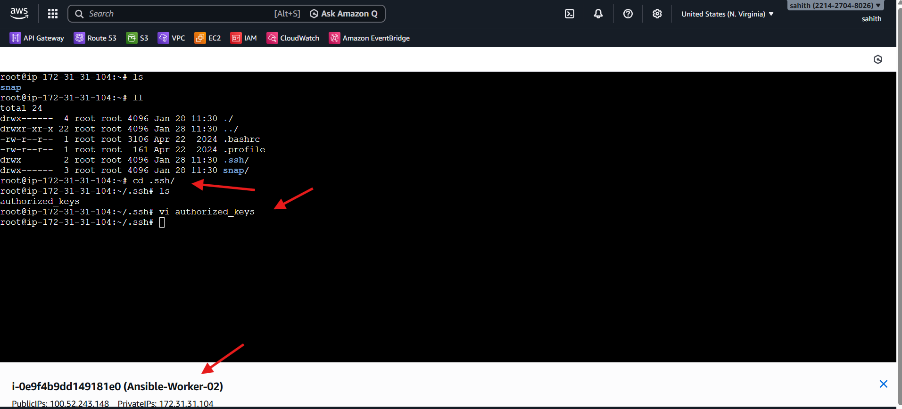

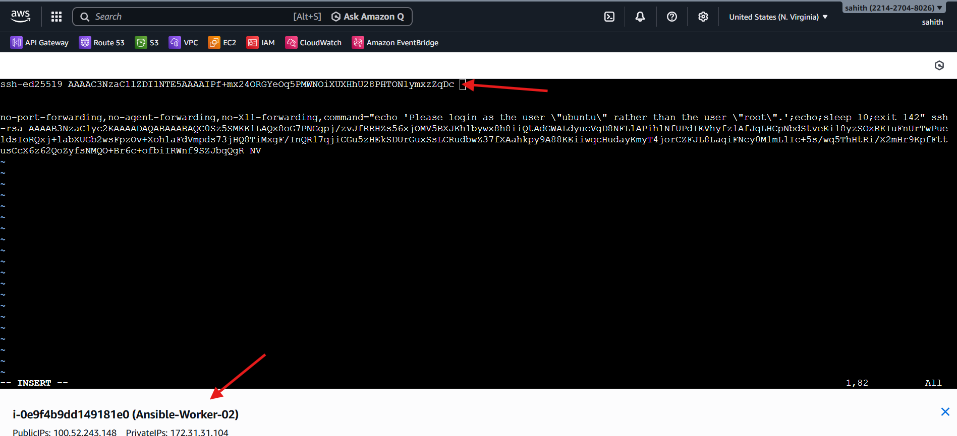
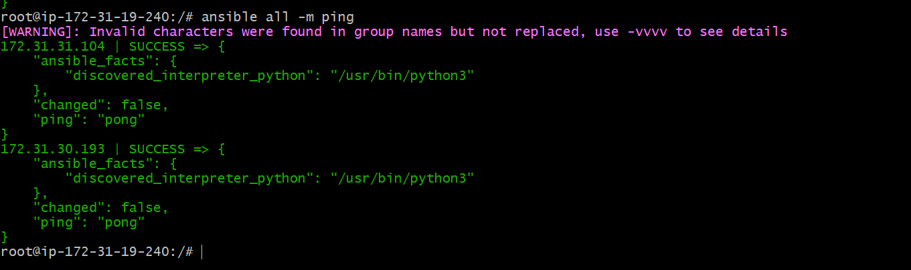
Issues Faced
- ssh -keygen typo (resolved by using ssh-keygen)
- yum command not found (Ubuntu uses apt)
- Existing SSH key conflict (resolved by overwrite)
- Warning for invalid group names (non-blocking)
Conclusion
Successfully provisioned EC2 instances on AWS, configured an Ansible Master and worker nodes, installed and configured Ansible on Ubuntu 24.04, enabled passwordless SSH authentication, and validated connectivity using Ansible ad-hoc commands. The environment is now ready for executing Ansible playbooks and managing infrastructure at scale.
- Execute the adhoc command shared in #dvps-cloud-documents-12 Channel.
# To check the connectivity between slaves
ansible all -m ping
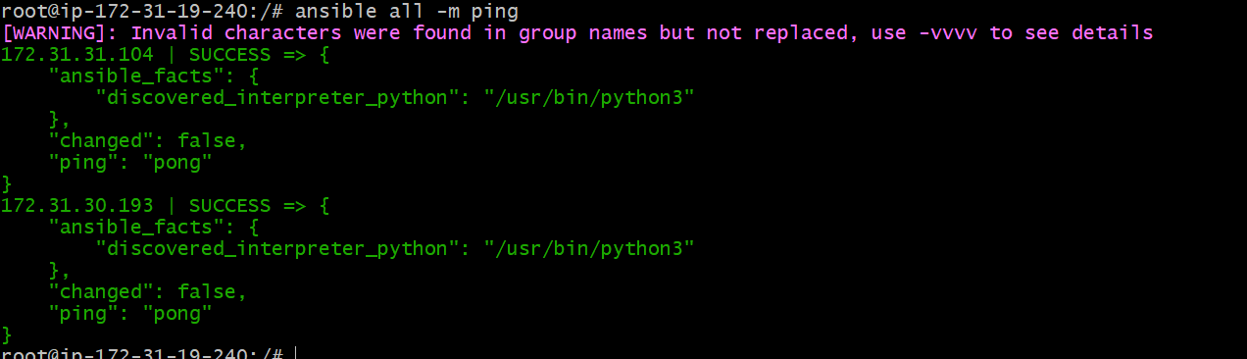
# How to gather facts of slave machine
ansible all -m setup
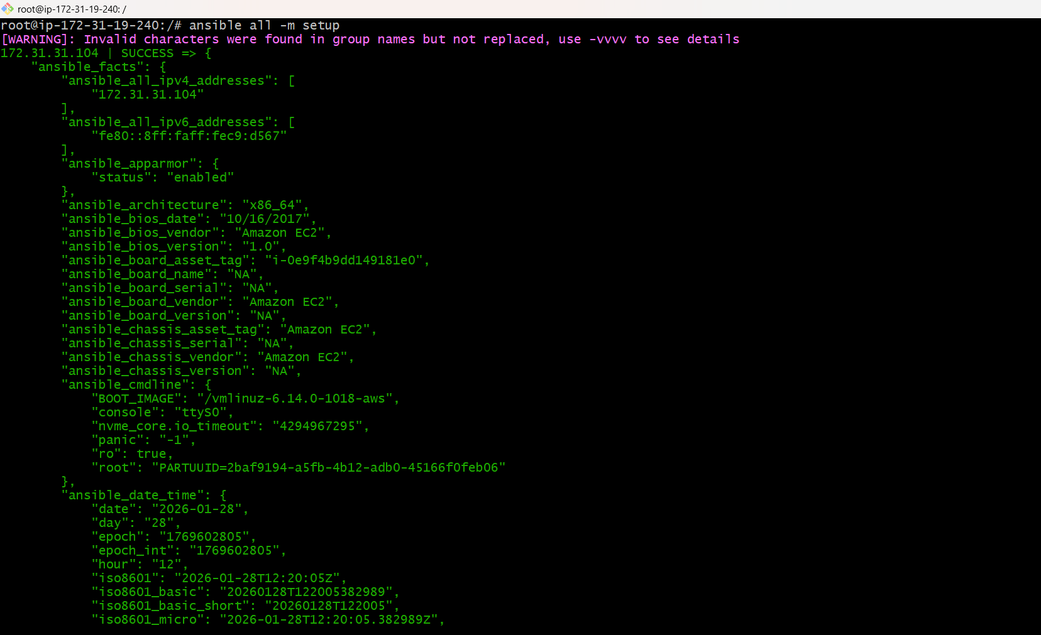
# TO check the uptime of a slave machine
ansible all -a uptime
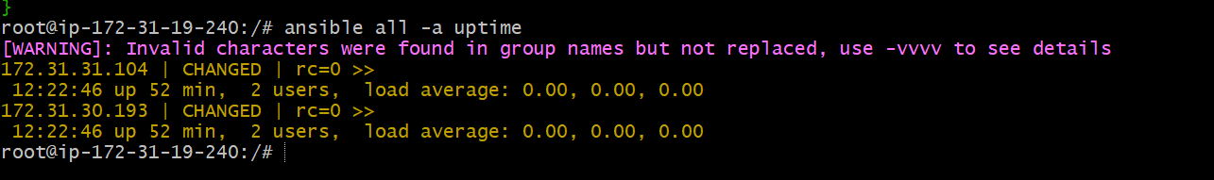
Ansible all -m ping -vvvv
—-> to check with all log details
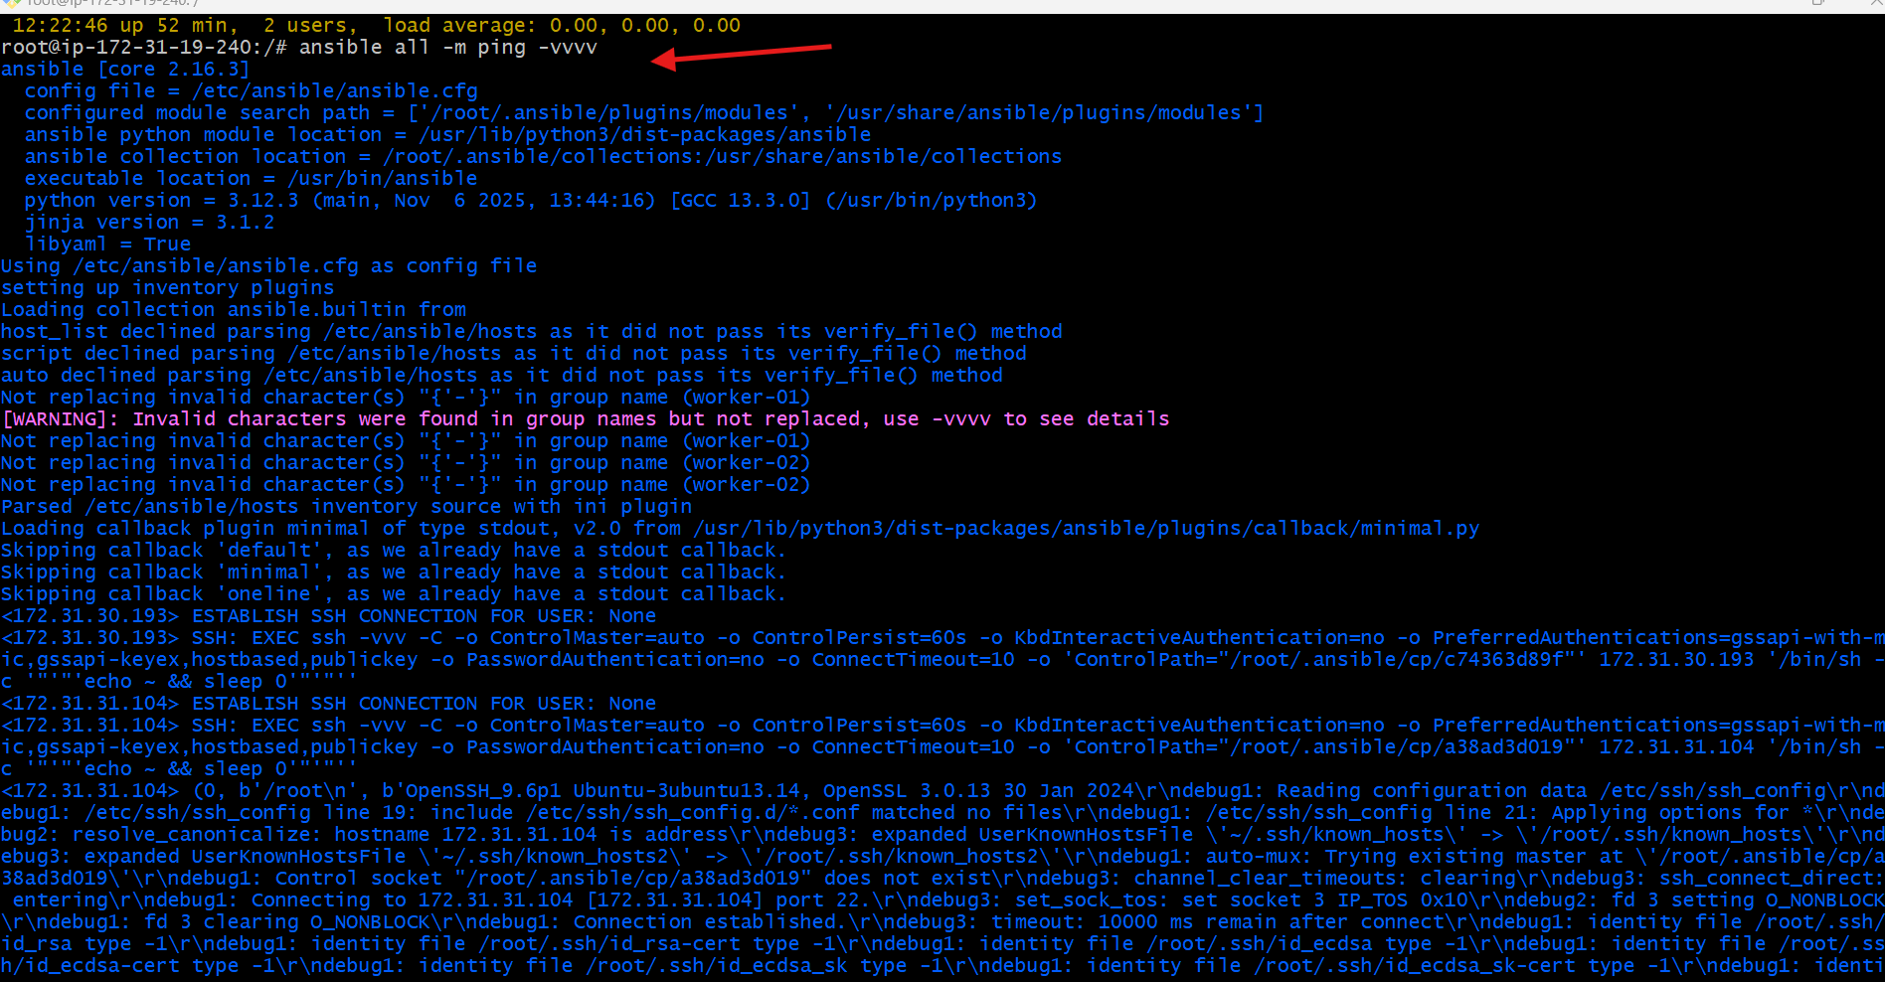
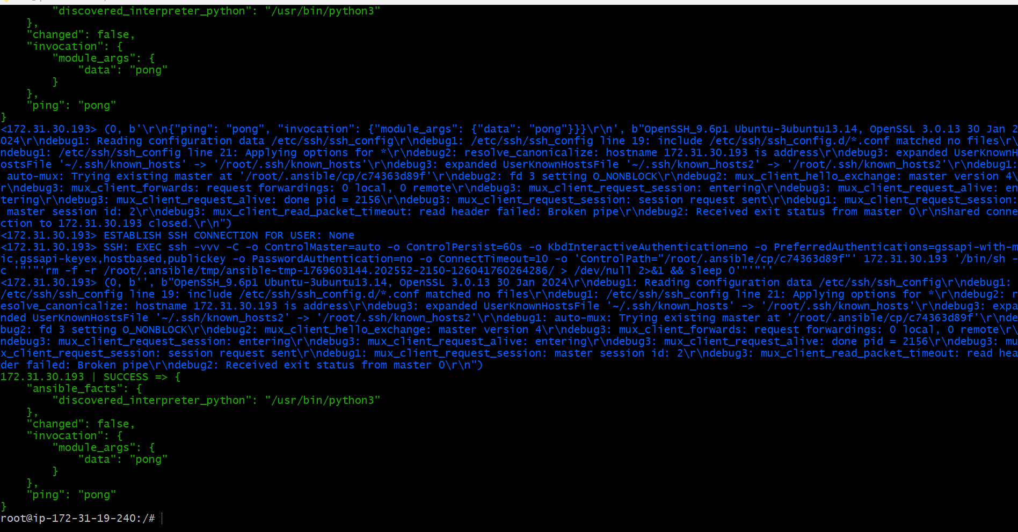
# Check the free memory or memory usage of host
ansible all -a "free -m"
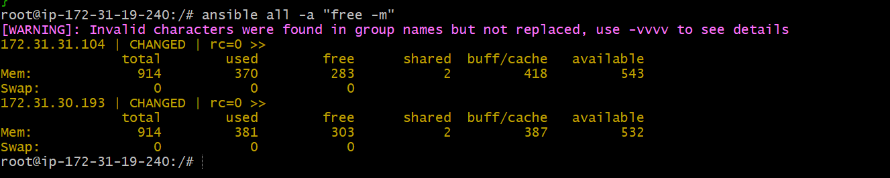
#Create directory using shell module
ansible all -m shell -a "mkdir ansible.conf"
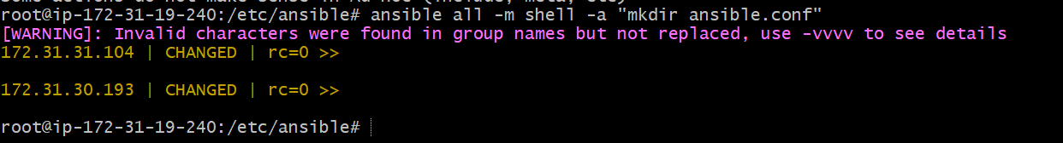
--> what it does it will create ansible.conf directory in all
workers server
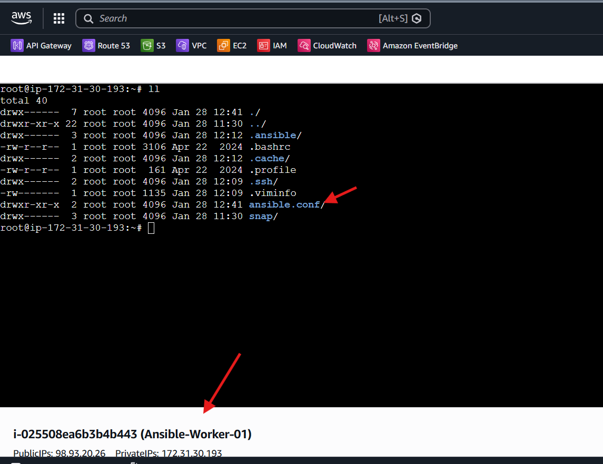
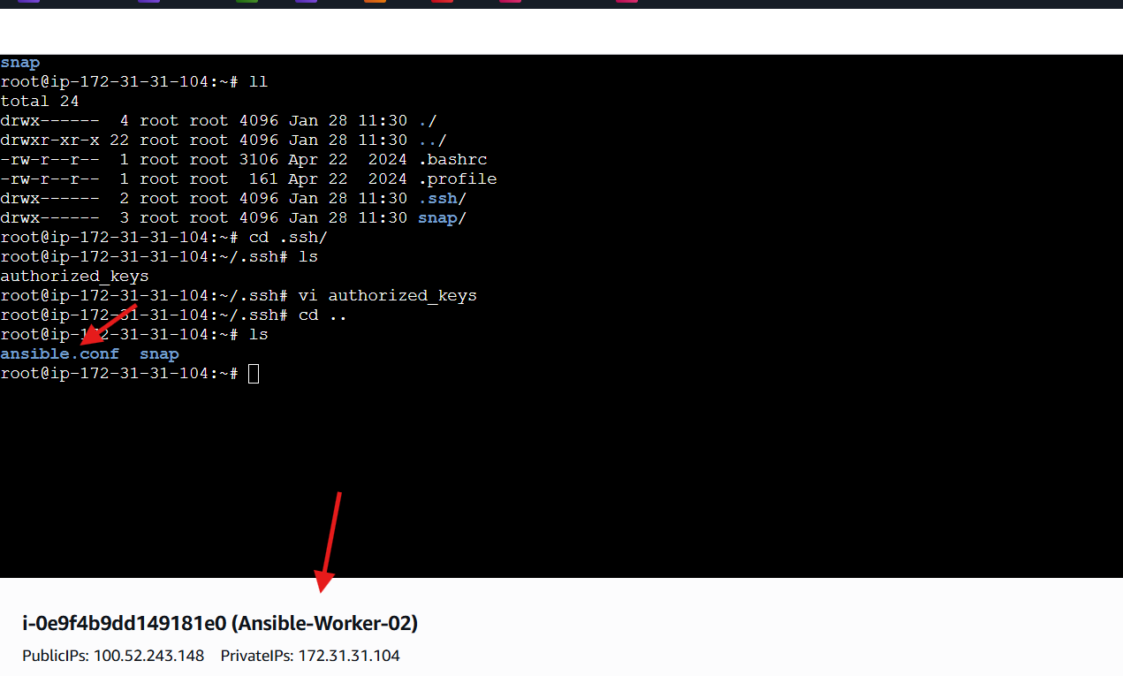
# Install a package using yum command
ansible all -m yum -a "name=httpd state=installed"
—> iam using ubuntu
First update:
ansible all -m apt -a 'name=apache2 state=latest
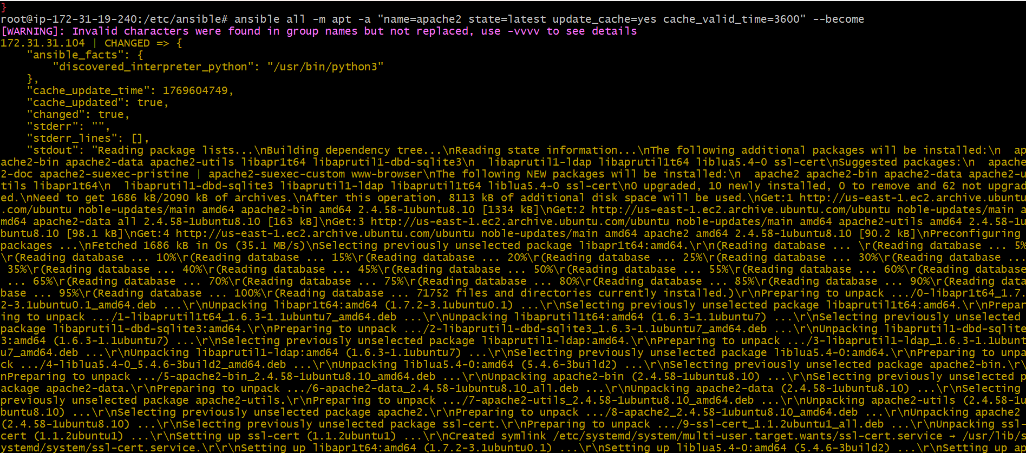
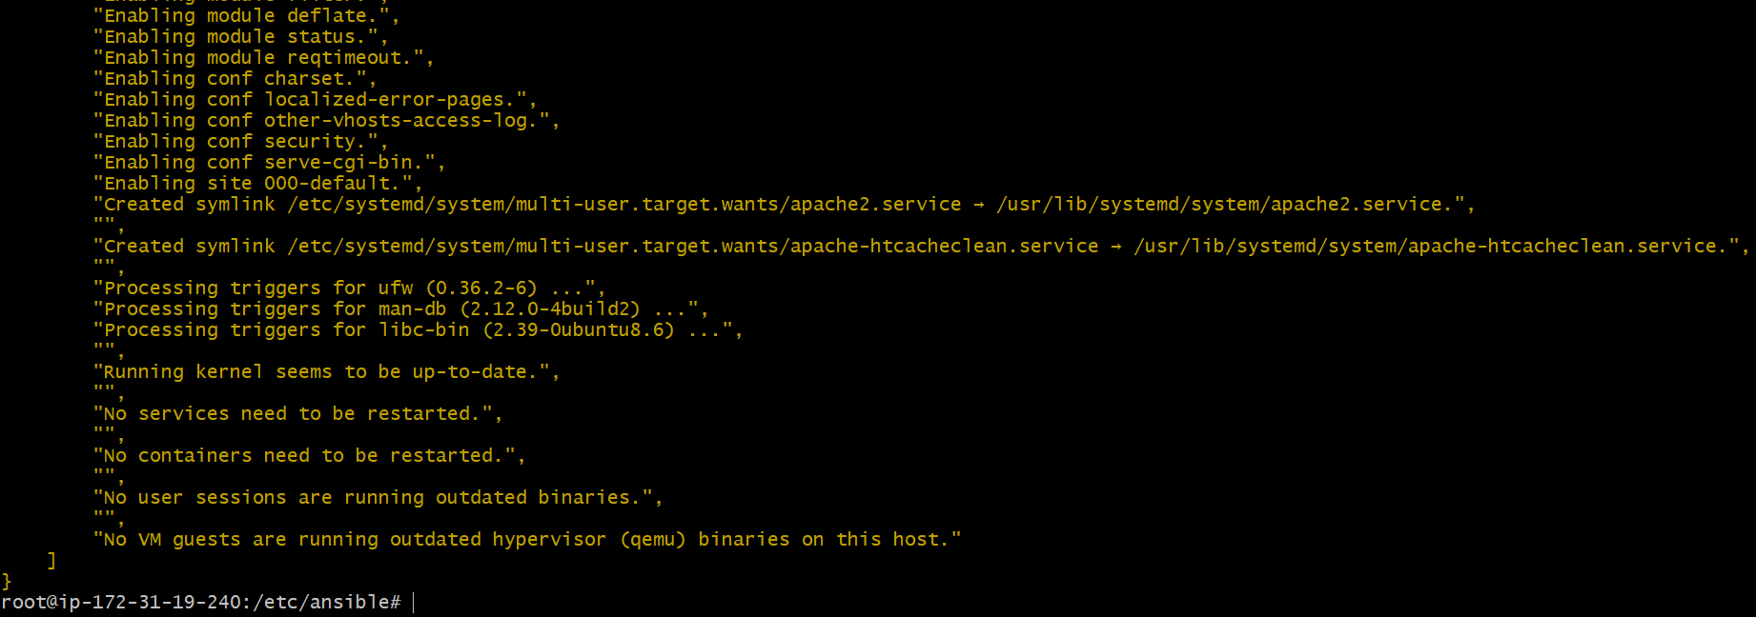
—-> now check your other workers servers if apache2 package
is installed or not
—->worker1
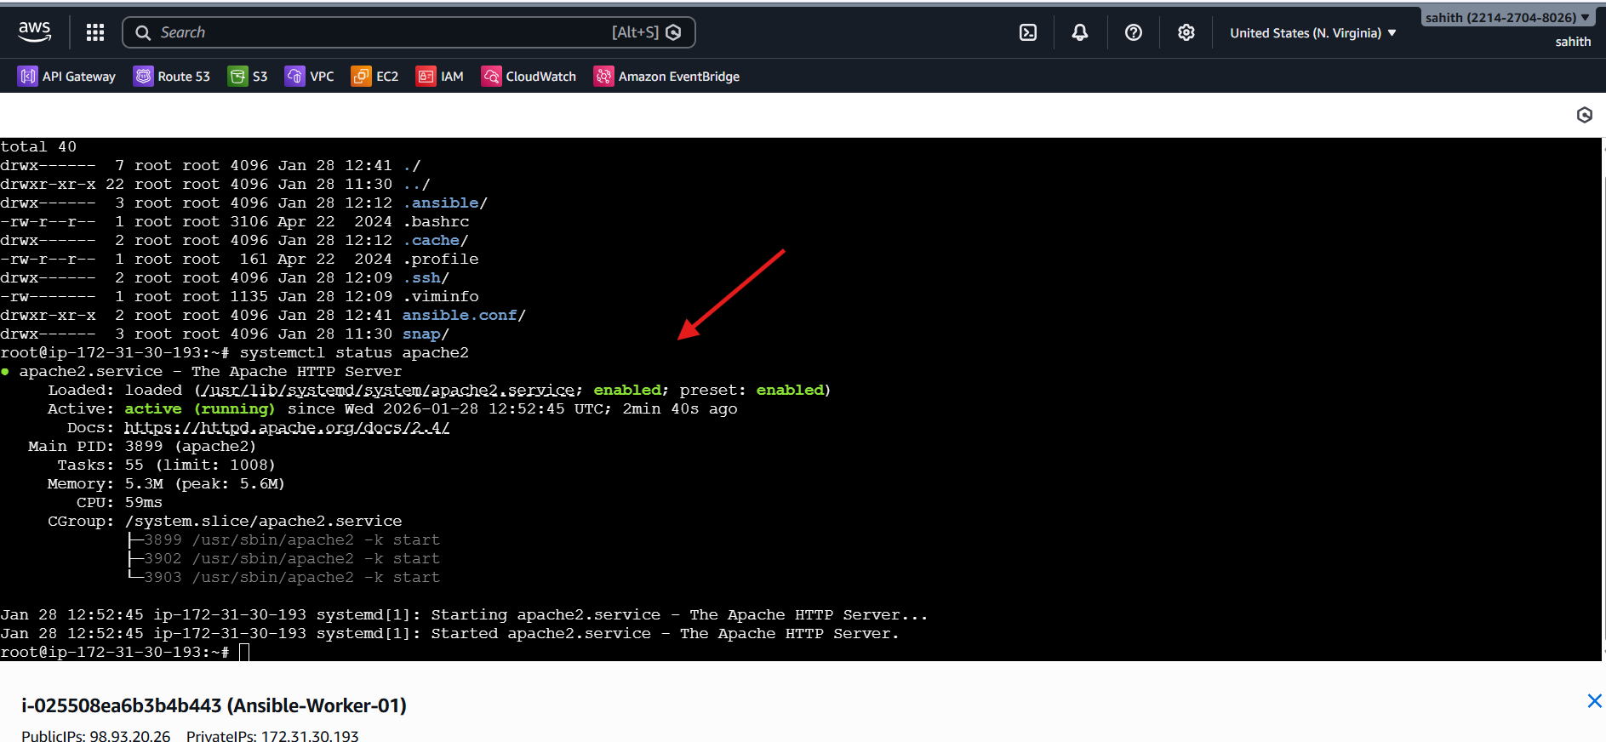
—-> now check your other workers servers if apache2 package
is installed or not
—->worker2
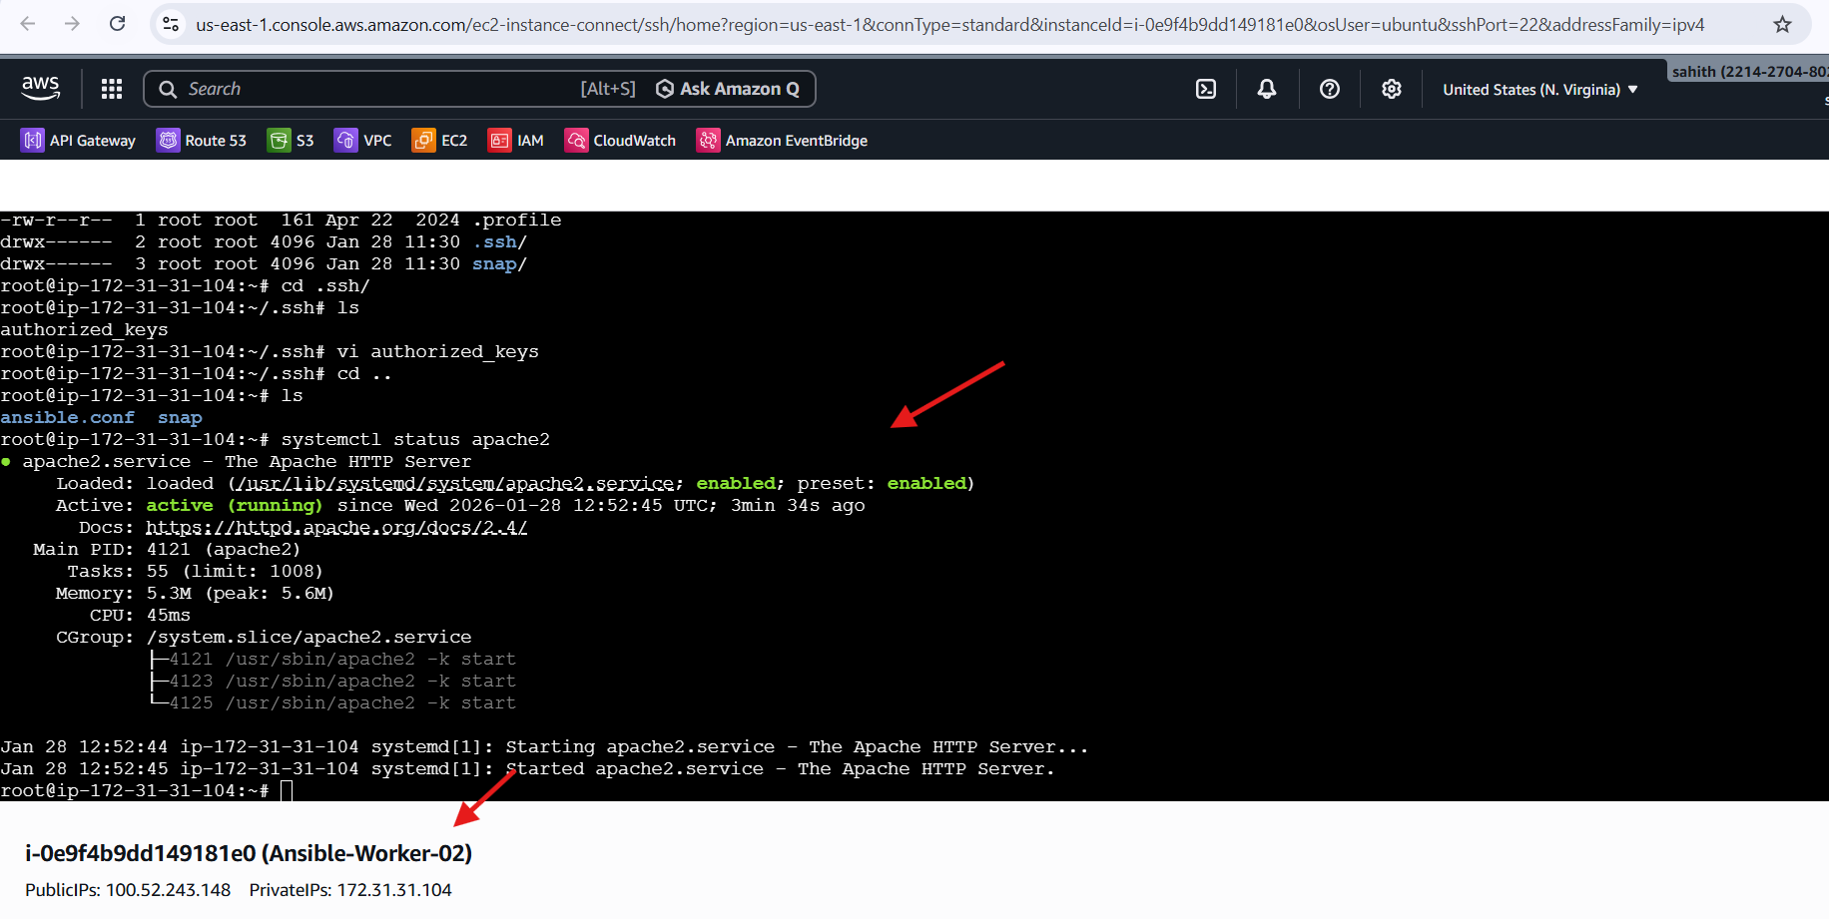
# Start or stop the service
# To Start
ansible all -m service -a "name=apache2 state=started
enabled=yes"
# To Stop
—-> ansible all -m service -a "name=apache2 state=stopped
enabled=yes"
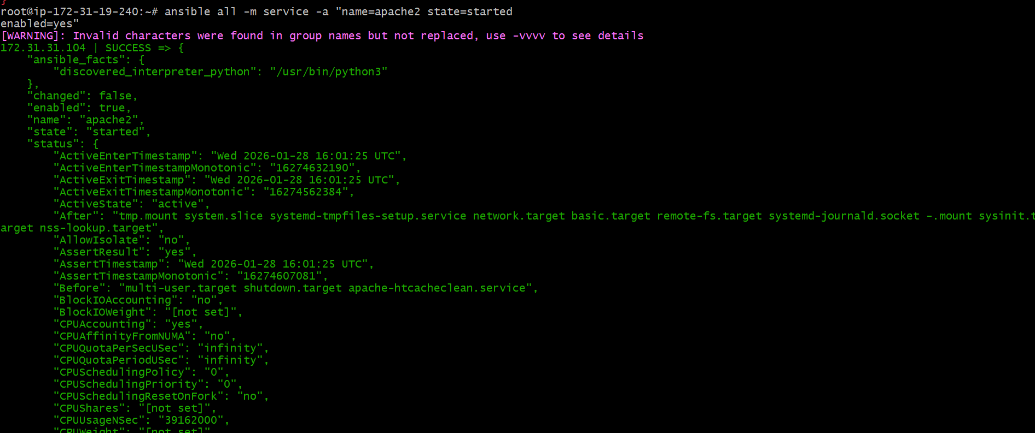
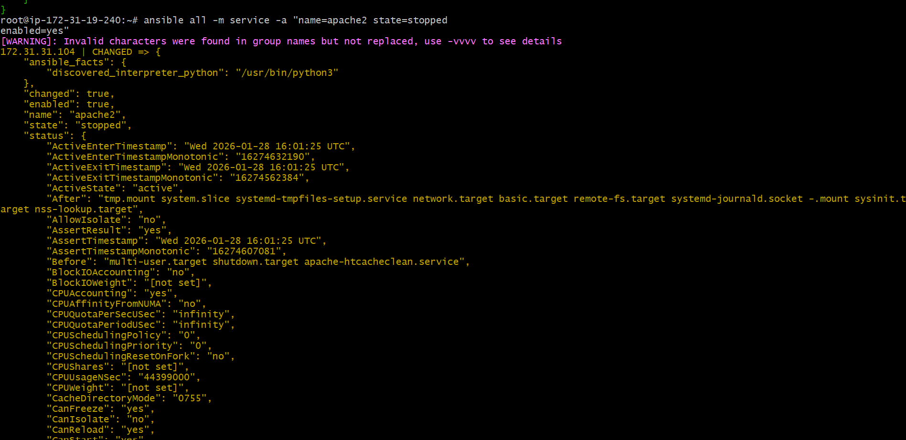
—> check your workers-01
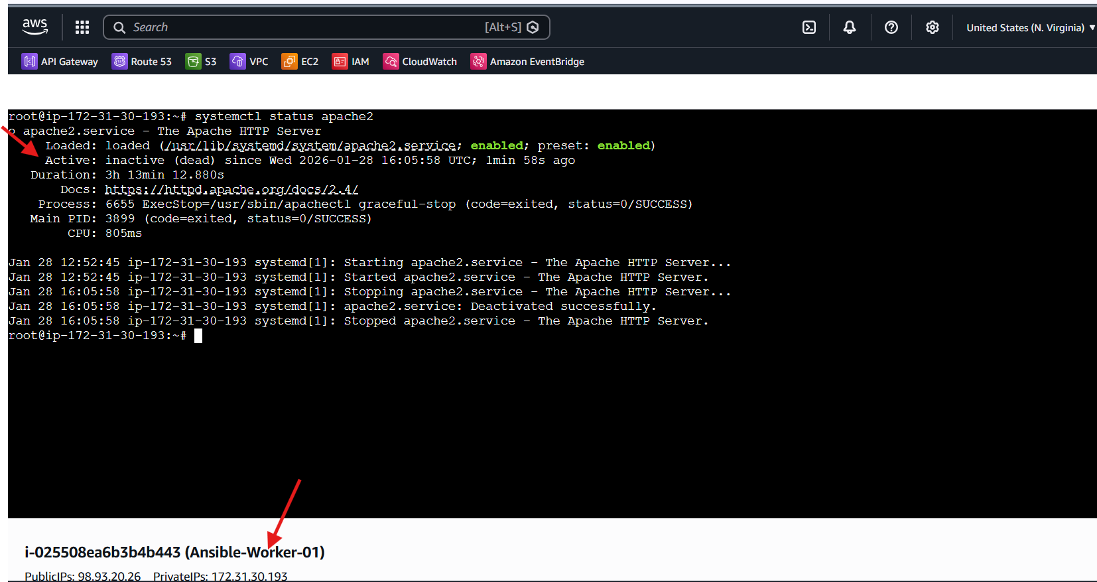
—> check your workers-02
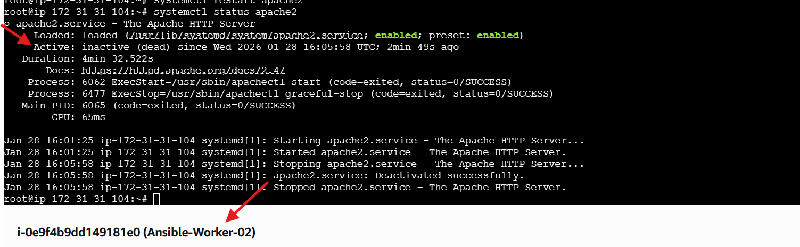
Create the user on ALL servers
—> ansible all -m user -a "name=weblogic state=present"
Verify user exists
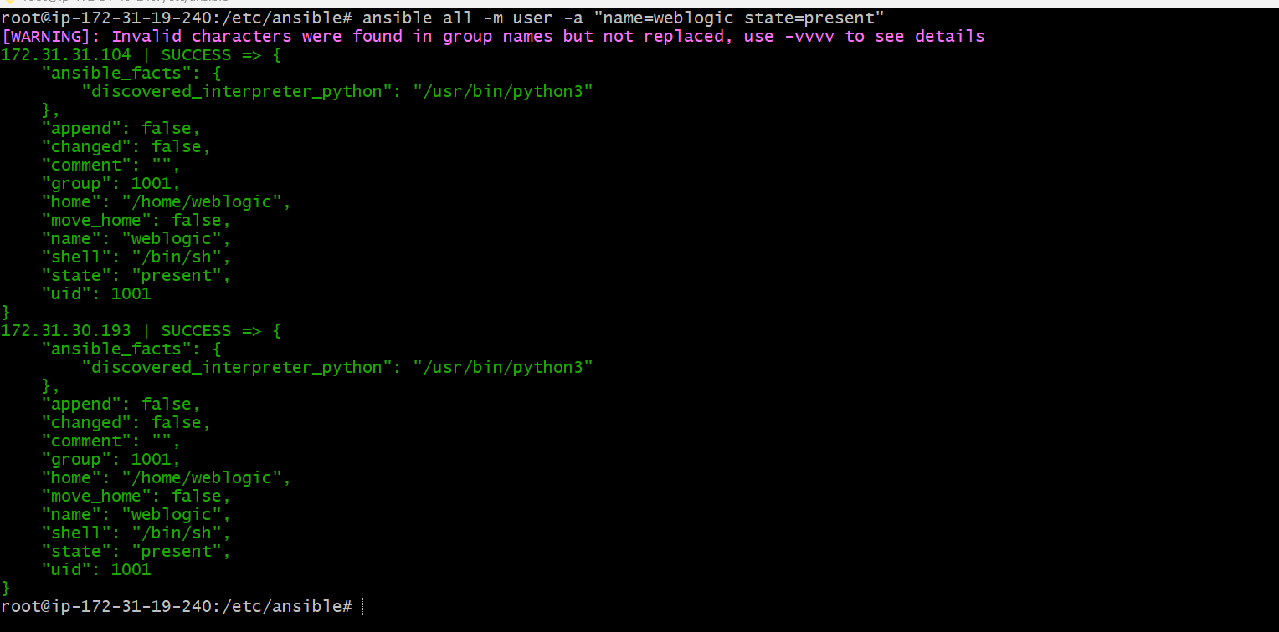
Verify user exists
ansible all -m shell -a "id weblogic"
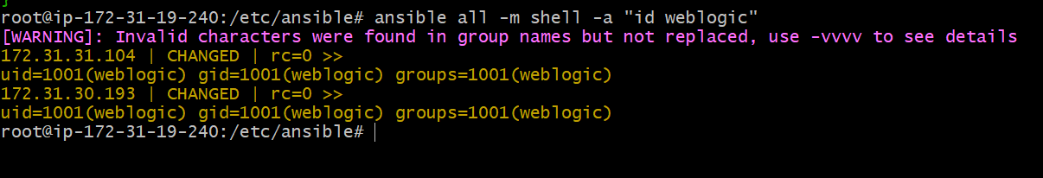
# Create a file with 755 permission
ansible all -m file -a "path=/root/testfile state=touch
mode=0755"
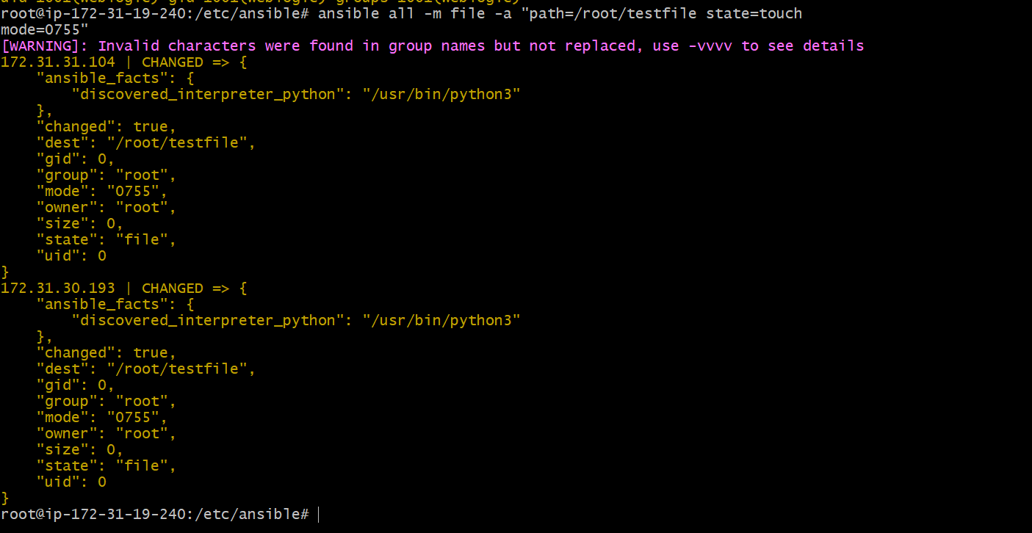


# Change ownership of a file
ansible all -m file -a "path=/root/testfile group=weblogic
owner=weblogic" -b
Tips: -b is the option for become and by default it will become
root user
–K is to tell ansible to ask for SUDO password
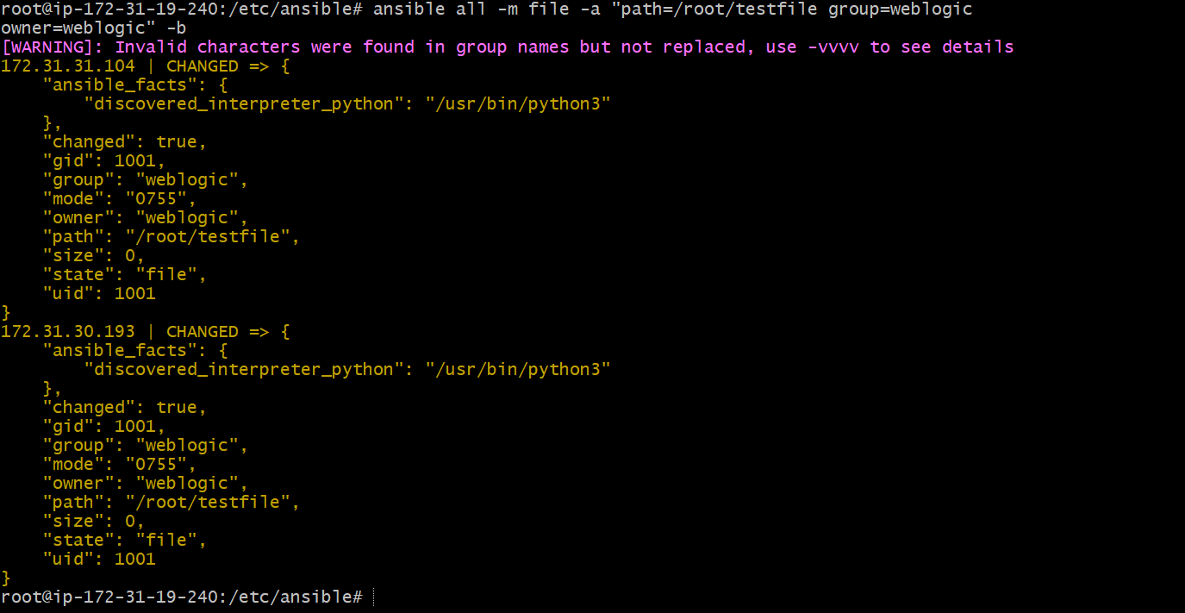
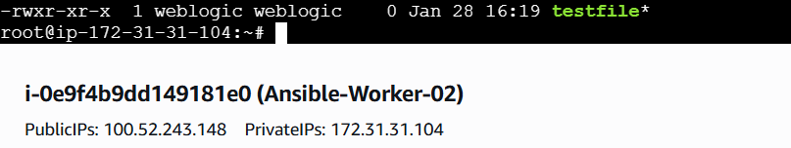
# Create a Linux user group
ansible all -m group -a "name=test state=present" -b -K
